University of Mumbai Examination Summer 2022
Time : 2 hours 30 minutes ECC404:SIGNALS AND SYSTEM Max. Marks :80

Q1. | Choose the correct option for the following questions . All the questions are compulsory and carry equal marks.
1. | A discrete signal is said to be even or symmetric if x(-n) is equal to
Option A | x(n)
Option B | –x(n)
Option C | –x(-n)
Option D | 0
2. | Under what conditions the three signals x(t), y(t) and z(t) with period t1 t2 and t3 respectively are periodic?
Option A | t1/t2/t3= rational
Option B | All the ratios of the three periods in any order is rational
Option C | t1/t2 is rational
Option D | t1/t2= t2/t3
3. | What is the period of the signal: 2cost/6?
Option A | 16π
Option B | 10π
Option C | 8π
Option D | 12π
4. | After converting the input and output to a dummy variable, the next step of convolution is
Option A | Shift the impulse response
Option B | Changing the dummy variables

Option C | Shifting any one of the signals to left side i.e towards the negative direction
Option D | Shift the input
5. | The continuous time system described by the equation y(t) = x(t^2) comes under which category
Option A | causal, linear and time varying
Option B | non causal, linear and time-variant
Option C | non causal, non-linear and time-invariant
Option D | causal, non-linear and time varying
6. | Find auto correlation of x(n)= { 1,2,3,4}
Option A | 4, 11, 20, 30, 11, 20, 4
Option B | 4, 11, 20, 30, 20, 11, 4
Option C | 4, 20, 3, 5, 11, 2, 4
Option D | 4, 2, 11, 5, 3 ,20, 4
7. | Find circular convolution of periodic signals x(n)= {1,2,3,4} and h(n)= {2,2,1,1}
Option A | 15,13,12,17
Option B | 17,2,13,5
Option C | 15,13,15,17
Option D | 5,13, 2 ,17
8. | What is the convolution of a signal with an impulse?
Option A | A new signal
Option B | Signal multiplied by impulse
Option C | Impulse
Option D | Signal itself
9. | Which of the following responses of an LTI system does not depend on initial conditions?

Option A | Natural response
Option B | free response
Option C | forced response
Option D | total response
10. | The Fourier transform of a function is equal to its two-sided Laplace transform evaluated
Option A | On the real axis of the s-plane
Option B | On the line parallel to the real axis of the s-plane
Option C | On the imaginary axis of the s-plane
Option D | On the line parallel to the imaginary axis of the s-plane
11. | Which of the following is an energy signal?
Option A | x(t)=A e^{jΩt}
Option B | x(t)=A sin Ωt
Option C | x(t)=B cos Ωt
Option D | x(t)=e^{-at} u(t)
12. | Y (t) = x (t/5) is
Option A | Amplitude scaled signal by factor 1/5
Option B | Time shifted signal
Option C | Expanded signal
Option D | Compressed signal
13. | The Fourier transform of a x(t)= e^{7t} u(-t) function is given as:
Option A | F (jω) = 1/(7+jω)
Option B | F (jω) = 7/(1+jω)
Option C | F (jω) = 7/(1-jω)
Option D | F (jω) = 1/(7-jω)
14. | In the equation x (t) = be^at if a < 0, then it is called

Option A | Decaying exponential
Option B | Both Growing and Decaying exponential
Option C | Complex exponential
Option D | Growing exponential
15. | Find the Z-transform of δ(n+3).
Option A | 1
Option B | z
Option C | z2
Option D | z3
16. | The step function u (t) is integral of with respect to time t.
Option A | Exponential function
Option B | Impulse function
Option C | Ramp function
Option D | Sinusoidal function
17. | Find the Z-transform of u(-n).
Option A | 1/(1-z)
Option B | 1/(1+z)
Option C | z/(1-z)
Option D | z/(1+z)
18. | For what kind of signals one sided z-transform is unique?
Option A | All signals
Option B | Anti-causal signal
Option C | Causal signal
Option D | Non-causal
19. | What is the one-sided z-transform of x(n)=δ(n-k)?

Option A | 0
Option B | 1
Option C | z-k
Option D | zk
20. | Linear convolution between two sequences x₁(n) = {− 1⏟ ,1,2, -2} and  𝗍  x₂ (n) = {0.5,1⏟ ,-1,2,0.75} is  𝗍
Option A | {-0.3, − 0. 6⏟ , 3, − 2, − 2. 75, 6. 75, − 2. 5, − 1. 6}  𝗍
Option B | {-0.1, − 0. 5⏟ , 3, − 4, − 2. 75, 9. 75, − 2. 5, − 1. 5}  𝗍
Option C | {-0.5, − 0. 5⏟ , 3, − 2, − 2. 75, 6. 75, − 2. 5, − 1. 5}  𝗍
Option D | {-0.5, − 0. 4⏟ , 1, − 2, − 2. 75, 6. 75, − 2. 5, − 1. 5}  𝗍
21. | Find the final value, x(∞) in time domain for the s-domain signal X(s)=s/(s²+4).
Option A | 0
Option B | 1
Option C | 0.25
Option D | 1.25
22. | Which of the following systems is stable?
Option A | y(t) = exp(x(t))
Option B | y(t) = log(x(t))
Option C | y(t) = tx(t) + 1
Option D | y(t) = sin(x(t))
23. | The convolution of u(n) with u(n-4) at n=5 is
Option A | 5
Option B | 2
Option C | 1

Option D | 0
24. | The samples of a cosine wave at zero frequency are equivalent to samples of
Option A | Sine wave
Option B | A DC signal
Option C | A cosine wave
Option D | An unknown signal
25. | Determine whether the signal, x(t)=3 cos 2 𝑡 + 7 cos 5 π t is periodic or not
Option A | Non-Periodic
Option B | Periodic
Option C | Rational
Option D | Irrational
26. | If input to a system is not bounded , then system is
Option A | stable
Option B | Unstable
Option C | Cannot be tested
Option D | ideal
27. | Which one of the following systems is causal?
Option A | y(t)=x(t)+x(t-3)+x(t²)
Option B | y(n)=x(n+2)
Option C | y(t)=x(t-1)+x(t-2)
Option D | y(n)=x(2n²)
28. | Find the Nyquist rate and Nyquist interval for the signal f(t)=(sin 500πt) / πt.
Option A | 500 Hz, 2 sec
Option B | 500 Hz, 2 msec
Option C | 2 Hz, 500 sec

Option D | 2 Hz, 500 msec
29. | The impulse response h (t) of an LTI system is given by e^{-2t} u(t). What is the step response?
Option A | y(t) = ¹⁄₂ (1 – e^{-2t}) u (t)
Option B | y(t) = ¹⁄₂ (1 – e^{-2t})
Option C | y(t) = (1- e^{-2t}) u (t)
Option D | y(t) = ¹⁄₂ (e^{-2t}) u (t)
30. | Fourier transform is evaluation of Laplace transform along the axis in s-plane.
Option A | Real
Option B | Imaginary
Option C | Z domain
Option D | S domain
31. | Determine the convolution of x₁(t)= e ^{-2t} u(t) and x₂(t)=e ^{-6t} u(t), using Fourier Transform?
Option A | 0.25(e^{-2t} – e ^{-6t}) u(t)
Option B | 0.15(e^{-2t} – e ^{-6t}) u(t)
Option C | 0.25(e^{-3t} – e ^{-6t}) u(t)
Option D | 0.35(e^{-2t} – e ^{-5t}) u(t)
32. | In IIR systems, the structure will give direct relation between time domain and z domain.
Option A | Direct form-I
Option B | Direct form
Option C | Linear phase
Option D | Direct form-II
33. | Where does the maximum value of auto-correlation function of a power signal occur?
Option A | At unity

Option B | At origin
Option C | At extremities
Option D | At infinity
34. | Determine the Time period of: x(t)=3 cos(20t+5)+sin(8t-3).
Option A | 2/5 sec
Option B | 1/10 sec
Option C | 1/20 sec
Option D | 2/4 sec
35. | Which among the following is a LTI system?
Option A | y(t)=x(t)cosπt
Option B | y(n)=x(n)+nx(n-1)
Option C | dy(t)/dt+ty(t)=x(t)
Option D | y(n)=x3 (n+1)
36. | ∂(at) = 1⁄a ∂(t), this property of unit impulse is called
Option A | Time scaling property
Option B | Time shifting property
Option C | Time reversal property
Option D | Amplitude scaling property
37. | For energy signal Select one
Option A | E= ∞
Option B | E=0
Option C | P=0
Option D | P= ∞
38. | The impulse response of a continuous time LTI system is H (t) = e-t u (t-2). The system is

Option A | Neither causal nor stable
Option B | Causal but not stable
Option C | Stable but not causal
Option D | Causal and stable
39. | Find the value of h[n]*d[n-5], d[n] being the delta function
Option A | h[n-4]
Option B | h[n-5]
Option C | h[n-2]
Option D | h[n+5]
40. | Which of the following is not a fourier transform pair?
Option A | u(t)↔πδ(ω)+ 1/jw
Option B | sgn(t)↔2/jω
Option C | A↔2πδ( ^{𝑤} )  2
Option D | G(t)↔sa( ^{𝑤τ} )  2

Q2 | Questions of 5 marks each
1 | State and prove any two properties of Fourier Transform.
2 | Determine the following systems are memory less, causal, linear or Time invariant y(t)=5x(t) +2
3 | Using Laplace Transform, determine the natural response of the system  represented by the following equations.  (d²y(t)/dt²) + 10 (dy(t)/dt) + 21 y(t) =8 x(t) , y(0)=2, (dy(t)/dt) = -3 at t=0
4 | Explain in brief the ROC conditions in Laplace Transform.
5 | Determine the autocorrelation of the CT signal given by x(t)=A rect (t/2).
6 | The Impulse response of DT system is given by h[n]= {1,2,3} and the  output response is given by y[n]= {1,1,2,-1,3}, Using Z-Transform, determine x[n] by long division method.
7. | Determine energy and power of signal x(t)= cos5wt

8. | Test the given system for linearity, causality,stability and time variance  y(t)=x( 2)  𝑡
9. | Find initial and final value of given Z domain signal  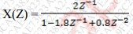
10. | Realize the following FIR system with minimum number of multipliers h(n)={-0.5,0.8,-0.5}
11. | List any 5 properties of Z transform
12. | FInd the response of time invariant system with impulse response h(n)={1,2,1,-1} to an input signal x(n)= {1,2,3,1}
13. | Explain any five types of elementary signals with mathematical equations  and graphical plot.
14. | Find the fundamental period of the signal  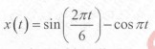
15. | Find x(-2t) and x(3t+2)  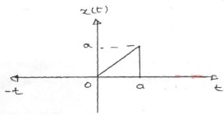
16. | Find the even and odd part of following signals  1) x(t)= 3+2t+5 2 2)sin2t+cost+sintcos2t  𝑡
17. | Determine energy and power of unit step signal
19. | Find laplace transform of u(t)-u(t-a)
20. | Find inverse Z transform of  X(z)= ¹  −1 −2  1−1.5𝑧 +0.5𝑧
21. | 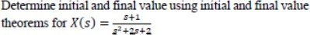

Q3. | Questions of 10 marks each
1. | Consider a causal LTI system with H(jω) =(jω+2⁾⁻¹. For a particular input x(t), this system produces output y(t)=e^{-2t} u(t)-e^{-3t} u(t). Find out x(t) using Fourier Transform.
2. | A LTI system has the following transfer function

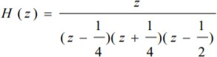
Give all possible ROC condition
- Show pole-zero diagrams
- Find impulse response of system
- Comment on the system stability and causality for all possible ROC’s
3. | Obtain Inverse Laplace Transform of the function X(s)=(3s+7)/ (s² -s-12) for following ROCs, also comment on the stability and causality of the systems for each of the ROC conditions.  Support your answer with appropriate sketches of ROCs.  - Rs(s)>4  - Re(s)<-3
4. | 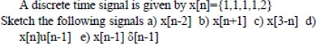
5. | Find the autocorrelation,power and PSD of x(t)= 3 cost +4 cos3t
6. | 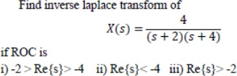
7. | 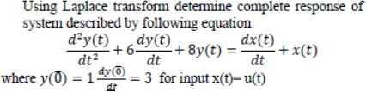
8. | 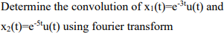
9. | 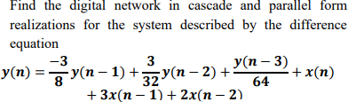

10. | 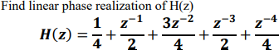
11. | Find fourier transform of sgn(t)
12. | Find the impulse response h(n) of the system if the spectrum is given by  H( 𝑗𝑤 1  𝑒 )= (1 + 𝑐𝑜𝑠𝑤)  3
13. | Determine fourier transform of the gate function  x(t)=A for |t|≤ ^{τ}  2
14. | Find initial and final value using laplace transform X(s)= 7𝑠+6  𝑠(3𝑠+5)
15. | Explain relation of ESD, PSD with autocorrelation
16. | Find response of LTI system if impulse response of the system is  h(t)=2 −3𝑡 −5𝑡  𝑒 𝑢(𝑡) for input x(t)=2𝑒 𝑢(𝑡) using fourier transform
17. | Determine fourier transform of  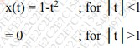
18. | Sketch the following signals for the given signal shown 1) x(-t) 2) x(2t+5) 3)x(2t) 4)x(t/2) 5) -2x(t)  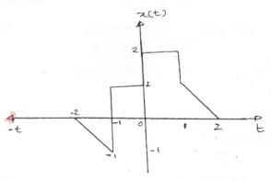
19. | 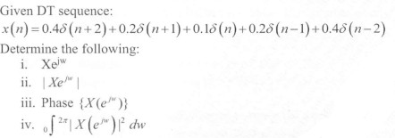

University of Mumbai

Examination Summer 2022

Time : 2 hours 30 minutes Max. Marks :80

Question | Correct Option
Q1. | A
Q2. | B
Q3. | D
Q4. | C
Q5. | B
Q6. | B
Q7. | C
Q8. | D
Q9. | C
Q10. | C
Q11. | D
Q12. | C
Q13. | D
Q14. | A
Q15. | D
Q16. | B
Q17. | A
Q18. | C
Q19. | C
Q20. | C
Q21. | A
Q22. | D

Q23. | B
Q24. | B
Q25. | A
Q26. | B
Q27. | C
Q28. | B
Q29. | A
Q30. | B
Q31. | A
Q32. | A
Q33. | B
Q34. | A
Q35. | D
Q36. | A
Q37. | C
Q38. | D
Q.39. | B
Q.40 | D

